I don't have Microsoft Office installed yet since this is a fresh reinstall of Windows, so I figured I'd use LC5 to demonstrate what this lab wants me to demonstrate. I created an account called “Test” with a password of 1234. I used LC5 to crack this password:
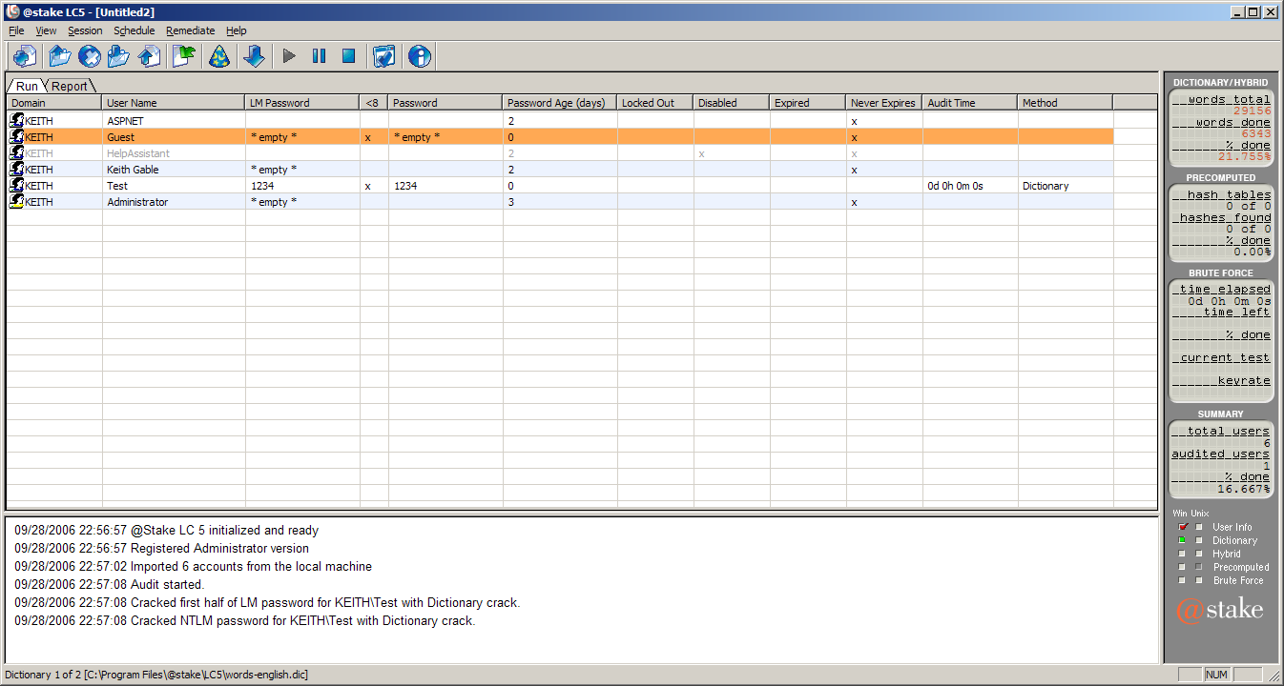
This password crack completed in less than a second. I expected slightly longer than that. Hopefully this will be sufficient to demonstrate weak passwords :).

Next major thing is to install Office :).

